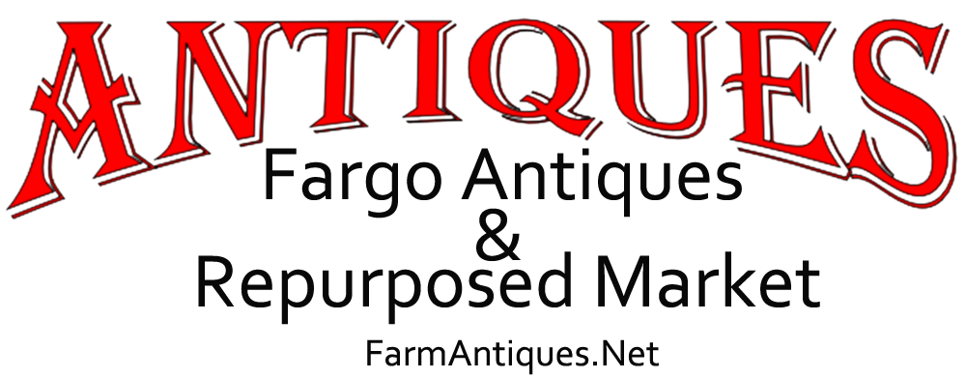
CONTACT  Kristi Bixby  701-356-9199  thefarmantiques@yahoo.com  FarmAntiques.Net | FOR IMMEDIATE RELEASE

Celebrating New Year’s - And Old Beers
Fargo, ND, January 17, 2020 — On Saturday, January 18th, Fargo Antiques & Repurposed Market begins New Year's Old Beers - a week-long celebration of all things beer.

Owner Kristi Bixby says, “Our vendors will be stocking their booths and cases with fresh items specifically for this major beer collector event. There will be plenty of antique and vintage beer bottles & cans, brewery mirrors & signs, beer lights & neon signs, mugs & steins, matchbooks & other brewing advertising ephemera, bottle openers & beer trays, and other breweriana.”

“As beer culture is closely tied to taverns and saloons, there will likely be an assortment of related vintage advertising ashtrays & other tobacciana collectibles,” says Deanna Dahlsad of Fair Oaks Antiques, one of the vendors at the antique mall. “With all the beer connections to casinos, the mob, brothels, prohibition, who knows what else we vendors might bring in!”

Vendors at Fargo Antiques & Repurposed Market are planning to restock items during the week-long event. “Our regular customers have known about this event and have already been looking for and buying beer items as soon they come in - so there’s pressure on us all to continue to bring in fresh beer collectibles all week long. And we aim to do it!” says Bixby.

The celebration of beer, beer culture, and local history culminates on Friday, January 24th, Beer Can Appreciation Day, honoring the day beer was first sold in cans back in 1935, with a book signing event.

Local author Alicia Underlee Nelson, of Prairie Style File, will be signing copies of her book, “North Dakota Beer: A Heady History”, from 4 - 6 pm.

A second book signing session will be held with Ms. Nelson on Saturday, January 25th from 1 pm to 3 pm.

Fargo Antiques & Repurposed Market, aka “The FARM,” is a locally-owned shop with over 60 local North Dakota and Minnesota vendors, each offering a wide variety of antiques and vintage items, collectibles, furniture, and repurposed handmade items. The marketplace also carries vintage candy, Cottage Paint, Watkins, and Howard furniture care products. Open seven days a week, from 10 am until 7 pm Monday through Saturday, and from noon until 6 pm on Sundays.

###

