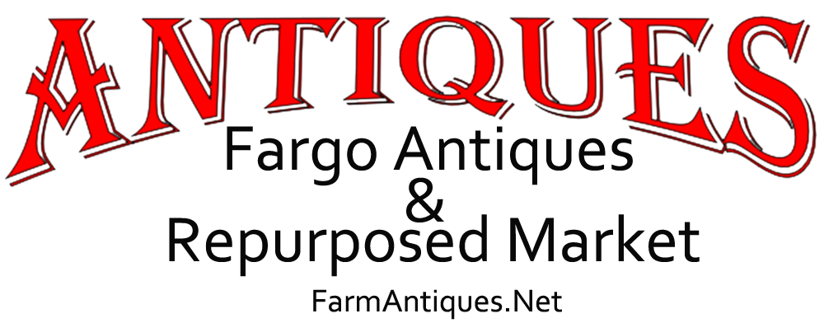
CONTACT  Kristi Bixby  701-356-9199  thefarmantiques@yahoo.com  FarmAntiques.Net | FOR IMMEDIATE RELEASE

Fargo Antique Shop Launches Events Series
Fargo, ND, January 17, 2020 — As Fargo Antiques & Repurposed Market, aka "The FARM", enters its fifth year of business, the popular local antique mall is branching out with events.

While The FARM has annually offered two outdoor flea market events, held on the third weekends of June and September, the list of events is expanding to include workshops, author signings, appraisal fairs, exhibits, and other hobby-based gatherings.

Owner Kristi Bixby says, “Antique malls have a long tradition of being more than ‘just’ a shopping place, but rather an experience. Folks who browse through the mall are continually discussing what they see. Decor and do-it-yourself inspirations, of course. But also our customers talk about their memories, about history - even explaining to younger generations just how that ‘old’ thing worked! Our events are just extensions of those things.”

Recent events have included a National Trivia Day celebration, a DIY Junk Journal Workshop, and a Vintage Succulent Garden Workshop, which was a joint event with Baker Garden & Gift of Fargo. “We are really proud to be an active part of our community and delighted to partner with other local businesses,” says Bixby.

Deanna Dahlsad, one of the vendors at The FARM, who with her husband hosts the Trash Or Treasure appraisal events, is excited by the expansion of events calendar. “After 30-plus years in this business, it’s refreshing to find an antique mall that really gets what it’s all about. Antiquing or junking is more than a pure materialistic act - it’s about more than the objects themselves. This is about the creativity of self-expression, the preservation of history, the passion of collecting, green living, and so much more! These events are very exciting to me because they bring more opportunities to connect with our FARM friends, with like-minded folks.”

For a complete listing of events see farmantiques.net/events.

Fargo Antiques & Repurposed Market is a locally-owned shop with over 60 local North Dakota and Minnesota vendors, each offering a wide variety of antiques and vintage items, collectibles, furniture, and repurposed handmade items. The marketplace also carries vintage candy, Cottage Paint, Watkins, and Howard furniture care products. Open seven days a week, from 10 am until 7 pm Monday through Saturday, and from noon until 6 pm on Sundays.

###

